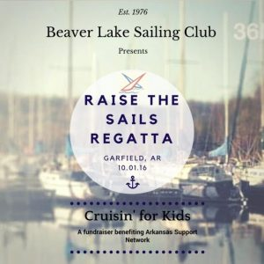
Greetings Club Members!
We are excited about the plans that are coming together for the 2016 Raise Your Sails Regatta to benefit the Arkansas Support Network on October 1st and 2nd. Our involvement with this organization began a couple of years ago through members of our own sailing club family, Rich and Laine Harper. If you’d like to know more about ASN, visit their website at www.supports.org/.
Several sailors have offered up cruises on their sailboats for our online auction, and items are still being secured for our silent auction to be held the day of the event. (Donations of items are still being accepted and are much appreciated – Contact Commodore Mike Carron at 479-644-9884).
The Regatta is scheduled for Saturday and Sunday, with registration beginning at 10:00 a.m., followed by the Skipper’s meeting at 11:00 a.m. A detailed race day schedule follows the registration form.
The final event of the day will be dinner catered by the club, capped off with a party in the pavilion with music provided by Earl and Them.
Please help us maximize our support for ASN by indicating how you plan to participate on the registration form, and return it along with your payment by September 24th to:
Betsy Harrell
12676 Oak Valley Dr.
Rogers, AR 727156
(479) 366-5738
Please note:
Dinner reservations made after Saturday the 24th date will increase to $30.00 each, and none can be accepted after Thursday, September 29th.

NAME:
CONTACT: (Phone) (email)

RACE REGISTRATION:
$40.00 (Includes dinner for two – additional meals for crew members may be purchased for $20.00 per person)
Boat Name:
Captain:
(# of Additional Meal Reservations @ $20.00 each)
Total (Make checks payable to BLSC)

DINNER & (DANCING?) ONLY:
# of Meal Reservations @ $20.00 each (On or before Sept. 24th)
Total (Make checks payable to BLSC)
Dinner reservations made after Sept. 24th will be $30.00 each.
Dinner reservations cannot be accepted after Sept. 29th.

DONATION:
I will be unable to attend, but I would like to help the club support the Arkansas Support Network. Enclosed is my check made payable to: Arkansas Support Network

King-of-the-Lake/Raise-Your-Sails Charity Regatta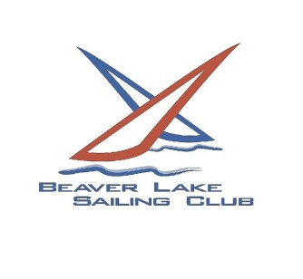
Sponsored by the Beaver Lake Sailing Club for the benefit of the
Arkansas Support Network.
Saturday, October 1. One long distance pursuit race to determine the 2016 King-of-the-Lake (there can be only one).
Registration 10:00 AM
Skipper’s Meeting 11:00 AM
First Flag 12:05 PM
Dinner at the Club 6:30 PM
Financial Report by the Regatta Committee 7:45 PM
King-of-the-Lake Award 7:55 PM
Live Music at the Club 8:00 PM-12:00PM
Sunday, October 2. Three, short course, ‘round-the-buoys, sprint races.
Skipper’s meeting 11:00 AM
First Flag 12:05 PM
Scoring. Scores for the King-of-the-Lake race, with double points, and the Sprint Races with be combined to determine the overall Regatta winners.
Trophies. First, second and third place trophies will be awarded for both the Cruising Fleet and the Performance Fleet (at the annual Club Christmas party). The King-of-the-Lake boat will have her name inscribed on the perpetual trophy, and her skipper awarded a commemorative medal on Saturday evening. (9/12/2016))

